UNIVERSITY OF CALIFORNIA, DAVIS

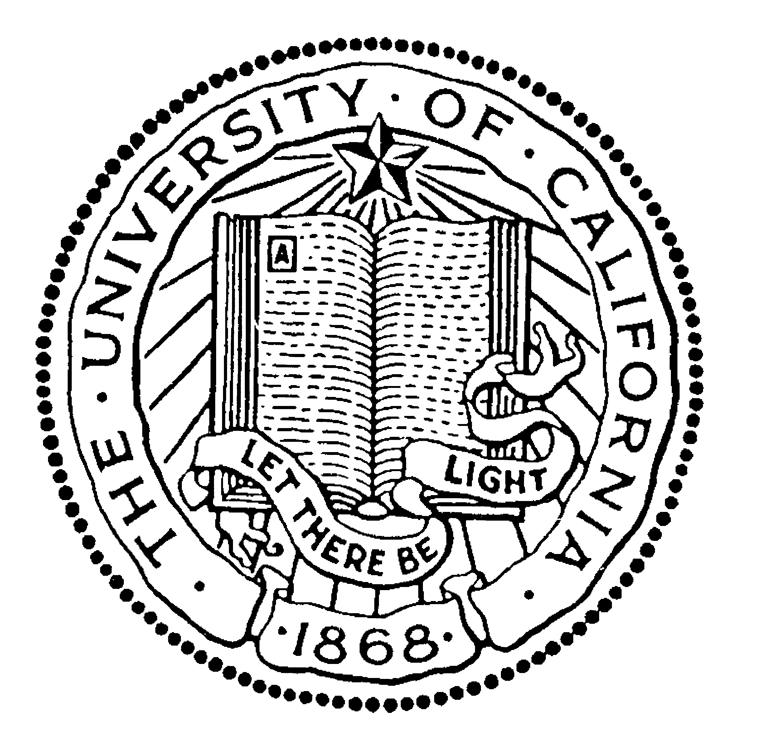

BERKELEY • DAVIS • IRVINE • LOS ANGELES • MERCED • RIVERSIDE • SAN DIEGO • SAN FRANCISCO SANTA BARBARA • SANTA CRUZ

Add address of university

Dear Admission committee,

I am writing to enthusiastically recommend Yanshu Wang as a graduate student at [name of university]. At UC Davis, Yanshu has excelled as a student and as a research assistant. This past summer, she learned an impressive array of field skills, including bird handling and measurement, temperature sensor use, and data collection and curation. She is ready to learn more and to take the next steps towards flourishing as a researcher.

I am a PhD candidate in the Department of Wildlife, Fish, and Conservation Biology at the University of California, Davis and have served as Yanshu’s supervisor during summer 2022. While she will graduate with a degree in Viticulture, she took the initiative to seek an internship with my project investigating the effects of heat on birds living in agriculture. While the skills were new to her, her care for the animals and passion for the science kept her determination to improve strong throughout the six-month-long field season. In the process, she gained experience with a wide variety of field ornithology skills including mist net use, bird handling and measurement, and meticulous data collection and curation. Over six months, she handled more than 100 nestling birds of three species, and in the process gained confidence and competence.

Beyond her research experience, Yanshu is a bright and enthusiastic community member. She helped keep morale up during hot and long days and built solid friendships with her co-workers. She also attended lab meetings during her volunteer tenure, which helped empower other undergraduate students to engage as well.

In summary, I am certain that Yanshu is ready for the training that will help her build an exceptional career. She has developed an impressive array of skills and is also collegial and collaborative. She is an excellent candidate for the [Masters/PhD] program at [university].

Please feel free to contact me with any questions or concerns.

Sincerely,

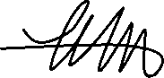

Katherine S. Lauck

PhD Candidate Dept. Wildlife, Fish, and Conservation Biology

1073 Academic Surge

One Shields Ave

Davis, CA 95616

katherinelauck@gmail.com; +1-540-923-0228